**KONGU ENGINEERING COLLEGE**

**(Autonomous)**

PERUNDURAI, ERODE 638060

**22GCL12-FOUNDATION LABORATORY**

**WEB LABORATORY**

ACADEMIC YEAR: 2023-2024

**PROJECT REPORT**

|  |
| --- |
| **csdb03** |

**TEAM NAME:**

|  |
| --- |
| **VIRTUAL HORIZON HUB** |

**TITLE:**

**KONGU ENGINEERING COLLEGE**

**(Autonomous)**

PERUNDURAI, ERODE 638060

**22GCL12-FOUNDATION LABORATORY**

**WEB LABORATORY**

ACADEMIC YEAR: 2023-2024

**PROJECT REPORT**

|  |  |  |
| --- | --- | --- |
| **Team Name** | **csdb03** | |
| **Project Title** | **VIRTUAL HORIZON HUB** | |
| **Name of the Students** | **MEHARUNSHIYA S** | **MUTHAMIL S** |
| **Roll Number** | **23CDR089** | **23CDR104** |
| **Programme / Branch** | **B.E - COMPUTER SCIENCE AND DESIGN** | |
| **Year / Semester** | **I / II** | |

**Day 1:**

# DESIGN A WEB PAGE USING BASIC HTML TAGS

**Aim:**

To design a web page using the basic HTML.

**Program:**

<!DOCTYPE html>

<html lang="en">

<head>

<meta charset="UTF-8">

<meta name="viewport" content="width=device-width, initial-scale=1.0">

<title>VIRTUAL REALITY</title>

</head>

<body bgcolor="lightblue">

<h1><center>VIRTUAL HORIZON HUB</center></h1>

<h3><center>Explore Beyond Boundaries with Virtual Horizon Hub</center></h3>

<p><center>Your gateway to immersive virtual experience and learning.</center></p>

<center><img src="/VR4 image.jpg"alt="VR image.jpg"</center>

<form>

<label for="Username">Username:</label><br>

<label for="Password">Password:</label><br>

<input type="submit" value="Submit">

</form>

<style>

table,th,td{

border:1px solid black;

border-collapse: collapse;

}

</style>

<table>

<tr>

<th>Industry</th>

<th>Application</th>

</tr>

<tr>

<td>Healthcare</td>

<td>Surgical Assistance</td>

</tr>

<tr>

<td>Aerospace and Defense</td>

<td>Mission Planning and Rehearsal</td>

</tr>

</table>

</table>

<h2>Benefits of VR</h2>

<ul>

<li>Therapeutic Applications</li>

<li>Pain Distractions</li>

<li>Enhanced Design and Prototyping</li>

</ul>

<h2>Advantages of VR</h2>

<ol>

<li>Cost Effective Stimulation</li>

<li>Remote collaboration</li>

<li>Architectural Visualization</li>

</ol>

<center><h4>REFERENCES &#8595</center></h4>

<p><center>3D MODELLING SOFTWARES</center></p>

<p><center>ACADEMIC JOURNALS</center></p>

<p><center>BOOKS</center></p>

<p><center>ONLINE RESOURCES</center></p>

</body>

</html>

**Output:**

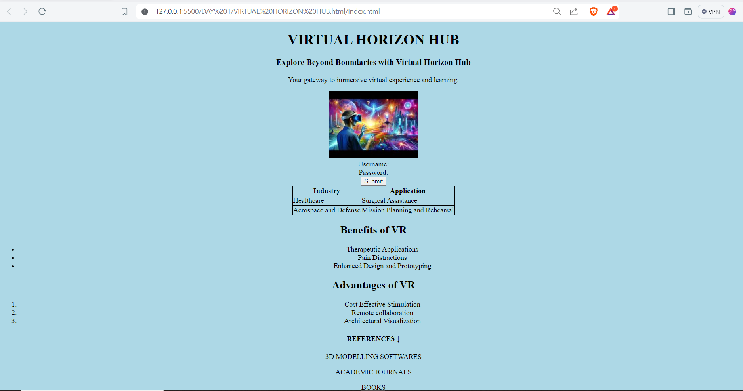

**Result:**

Thus a web page has been designed using the basic HTML Tags.

**Day 2:**

# DESIGN A WEB PAGE USING HTML AND CSS PROPERTIES

**Aim:**

To design a web page by applying different types of CSS properties.

**Program:**

**<!DOCTYPE html>**

**<html lang="en">**

**body, html {**

**margin: 0;**

**padding: 0;**

**height: 100%;**

**font-family: 'Arial', sans-serif;**

**color: #1d1b1b;**

**text-align: center;**

**background-color: lightblue;**

**}**

**h1, h3, p {**

**margin: 20px 0;**

**color: #333;**

**}**

**<nav>**

**<a href="home.html"> HOME </a>**

**<a href="signup.html"> SIGNPAGE</a>**

**<a href="login.html"> LOGINPAGE </a>**

**<a href="experience.html"> EXPERIENCE PAGE </a>**

**<a href="event.html"> EVENT PAGE </a>**

**<a href="learninghub.html"> LEARNING HUB </a>**

**<a href="communityforum.html"> COMMUNITY FORUM </a></center>**

**</nav>**

**nav {**

**margin: 20px 0;**

**}**

**nav a {**

**margin: 0 15px;**

**text-decoration: none;**

**color: #007bff;**

**font-weight: bold;**

**transition: color 0.3s;**

**}**

**nav a:hover {**

**color: #0056b3;**

**}**

**table {**

**margin: 20px auto;**

**border-collapse: collapse;**

**width: 80%;**

**background-color: #f8f9fa;**

**color: #333;**

**}**

**table, th, td {**

**border: 1px solid #333;**

**}**

**th, td {**

**padding: 10px;**

**text-align: center;**

**}**

**h2 {**

**margin-top: 40px;**

**}**

**ul, ol {**

**text-align: left;**

**display: inline-block;**

**margin: 0 auto;**

**padding: 0;**

**color: #333;**

**background: rgba(255, 255, 255, 0.8);**

**padding: 10px 20px;**

**border-radius: 8px;**

**}**

**img {**

**margin: 20px auto;**

**max-width: 100%;**

**height: auto;**

**display: block;**

**border-radius: 10px;**

**box-shadow: 0 4px 8px rgba(8, 8, 8, 0.851);**

**}**

**h4 {**

**margin-top: 40px;**

**color: #050303e1;**

**}**

**p {**

**margin: 5px 0;**

**}**

**Output:**

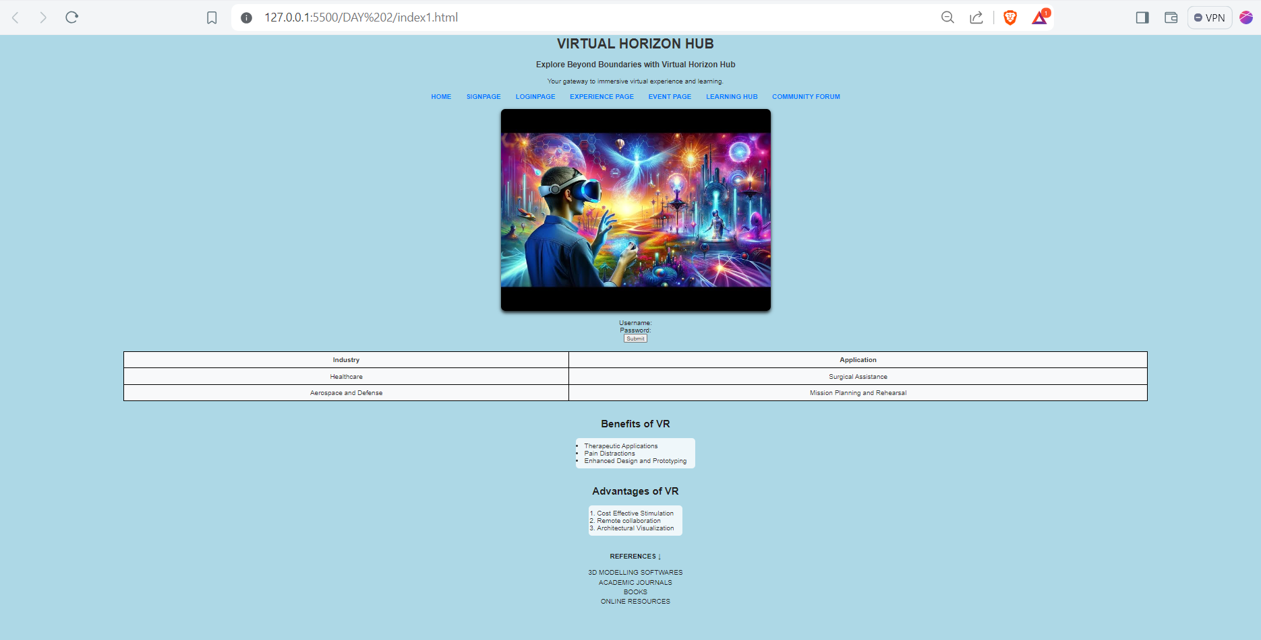

**Result:**

Thus a web page is designed by applying CSS properties.

**Day 3:**

# DESIGN A RESPONSIVE WEB PAGE USING BOOTSRAP FRAMEWORK

**Aim:**

To design a responsive web page using Bootstrap Framework.

**Program:**

**<!DOCTYPE html>**

**<html lang="en">**

**<head>**

**<title>Bootstrap 4 Website Example</title>**

**<meta charset="utf-8">**

**<meta name="viewport" content="width=device-width, initial-scale=1">**

**<link rel="stylesheet" href="https://cdn.jsdelivr.net/npm/bootstrap@4.6.2/dist/css/bootstrap.min.css">**

**<script src="https://cdn.jsdelivr.net/npm/jquery@3.7.1/dist/jquery.slim.min.js"></script>**

**<script src="https://cdn.jsdelivr.net/npm/popper.js@1.16.1/dist/umd/popper.min.js"></script>**

**<script src="https://cdn.jsdelivr.net/npm/bootstrap@4.6.2/dist/js/bootstrap.bundle.min.js"></script>**

**<style>**

**.fakeimg {**

**height: 200px;**

**background: #b2a0a0;**

**}**

**</style>**

**</head>**

**</style>**

**<body>**

**<div class="jumbotron text-center" style="margin-bottom:0">**

**<h1>VIRTUAL HORIZON HUB</h1>**

**<p>Your gateway to immersive virtual experience and learning.</p>**

**</div>**

**<nav class="navbar navbar-expand-sm bg-dark navbar-dark">**

**<a class="navbar-brand" href="#">HOME</a>**

**<button class="navbar-toggler" type="button" data-toggle="collapse" data-target="#collapsibleNavbar">**

**<span class="navbar-toggler-icon"></span>**

**</button>**

**<div class="collapse navbar-collapse" id="collapsibleNavbar">**

**<ul class="navbar-nav">**

**<li class="nav-item">**

**<a class="nav-link" href="login2.html">Login</a>**

**</li>**

**<li class="nav-item">**

**<a class="nav-link" href="signup2.html">signup</a>**

**</li>**

**<li class="nav-item">**

**<a class="nav-link" href="#">Experience page</a>**

**</li>**

**<li class="nav-item">**

**<a class="nav-link" href="eventpage.html">Event page</a>**

**</li>**

**<li class="nav-item">**

**<a class="nav-link" href="learninghub.html">Learning hub</a>**

**</li>**

**<li class="nav-item">**

**<a class="nav-link" href="contactus.html">Contact Us</a>**

**</li>**

**<li class="nav-item">**

**<a class="nav-link" href="#">About</a>**

**</li>**

**</ul>**

**</div>**

**</nav>**

**<div class="container mt-1" style="margin-top:30px">**

**<div class="row">**

**<div class="col-sm-4">**

**<h2>EXPLORE BEYOND BOUNDARIES WITH VIRTUAL HORIZON HUB</h2>**

**<h4>CONTENTS IN VR</h4>**

**<ul>**

**<li><p>Immersive Videos and Films</p></li>**

**<li><p>Games</p></li>**

**<li><p>Training Simulations</p></li>**

**<li>**

**<p>Virtual Tours and Walkthroughs</p>**

**</li>**

**<li><p>Social VR</p></li>**

**</ul>**

**<h3>Some Links</h3>**

**<ul class="nav nav-pills flex-column">**

**<li class="nav-item">**

**<a class="nav-link active" href="#">Active</a>**

**</li>**

**<li class="nav-item">**

**<a class="nav-link" href="#">Tools</a>**

**</li>**

**<li class="nav-item">**

**<a class="nav-link" href="#">Books</a>**

**</li>**

**<li class="nav-item">**

**<a class="nav-link" href="#">Gaming</a>**

**</li>**

**<li class="nav-item">**

**<a class="nav-link " href="#">Academic journals</a>**

**</li>**

**<li class="nav-item">**

**<a class="nav-link" href="#">3D modelling softwares</a>**

**</li>**

**<li class="nav-item">**

**<a class="nav-link " href="#">Online resources</a>**

**</li>**

**</ul>**

**<hr class="d-sm-none">**

**</div>**

**<div class="col-sm-8">**

**<h2>VIRTUAL REALITY</h2>**

**<div class="container mt-2">**

**<img src="/VR1 image.jpg" class="img-thumbnail" alt="VR image" width="304" height="236">**

**</div>**

**<h3>ABOUT</h3>**

**<p>VR creates a stimulated environment using computer technology.Unlike traditional user interfaces,VR places the user inside an experience,often through the use of a VR headset or other sensory equipment.</p>**

**<br>**

**<h2>FUTURE OF VR</h2>**

**<div class="container mt-3">**

**<img src="/VR 2 image.jpg" class="rounded-circle" alt="VR image" width="304" height="236">**

**</div>**

**<h4>ABOUT</h4>**

**<p>Higher Resolution Display: Enhancing visual quality.</p>**

**<p>Haptic Feedback: Providing tactile responses to interactions.</p>**

**<p>Social VR: Creating more shared virtual spaces for interaction.</p>**

**</div>**

**</div>**

**</div>**

**<div class="jumbotron text-center" style="margin-bottom:0">**

**<p>Have questions or need support? Reach out our team</p>**

**<a href="Virtualhorizonhub@2024">Virtual horizon hub @2024</a>**

**<h2>Follow Us on Social Media for Updates , New Release and More</h2>**

**<a href="#" target="_blank"><img src="./facebook.png" alt="Facebook"></a>**

**<a href="Facebook.com">Facebook.com</a>**

**<a href="#" target="_blank"><img src="./twitter.png" alt="Twitter"></a>**

**<a href="Twitter.com">Twitter.com</a>**

**<a href="#" target="_blank"><img src="./insta.jpg" alt="Instagram"></a>**

**<a href="Instagram.com">Instagram.com</a>**

**<a href="#" target="_blank"><img src="./linkedin.png" alt="LinkedIn"></a>**

**<a href="LinkedIn.com">LinkedIn.com</a>**

**</div>**

**</body>**

**</html>**

**Output:**

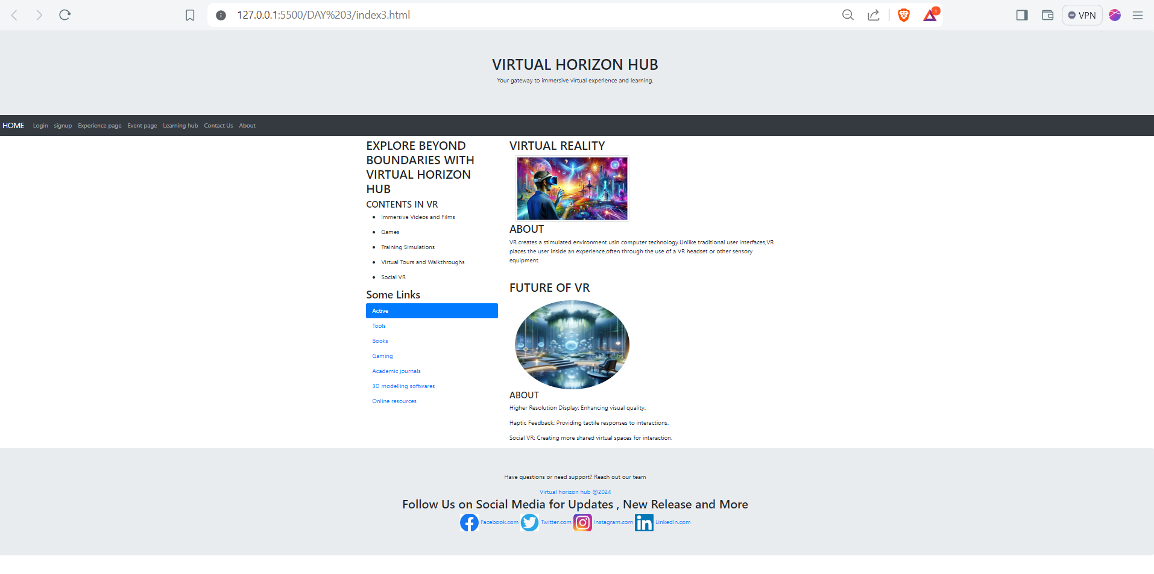

**Result:**

Thus a web page has been designed using Bootstrap framework.